**Terraform Commands-**

1. **Basic commands**
2. **Advanced commands**
3. **Workspace related commands**
4. **Terraform commands- State Perspective**

**-------------------------------------------------------------------------------------------------------------------------------**

**Basic Terraform Commands**

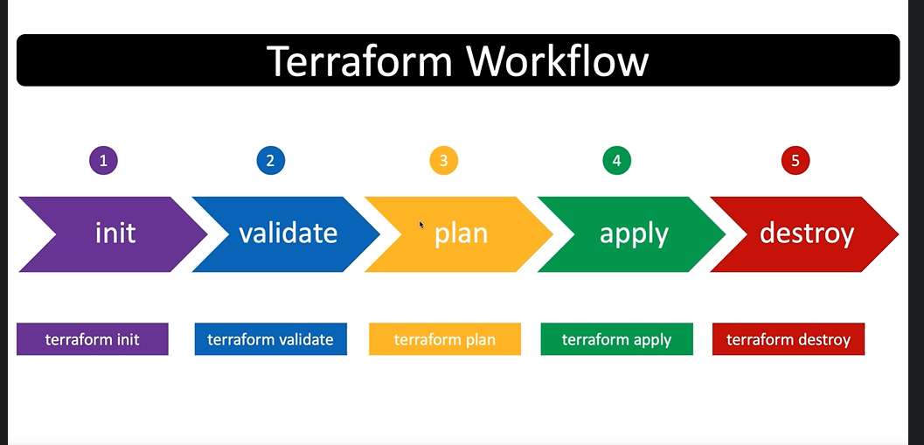

1. **terraform version-**to check terraform version

Syntax-

* terraform --version

1. **terraform init**: Initialized the terraform directory, based on provider it downloads all the cloud related plugins.

Whenever we do terraform init it creates ” .terraform file” and “.terraform.lock.hcl file”. In your local working directory.

*Details about above file check in the “terraform file document”.*

Syntax-

* terraform init
* terraform init -upgrade …. upgrade option to change provider version

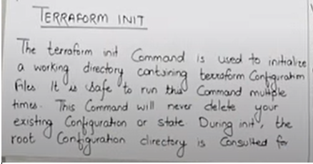

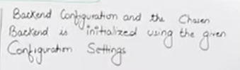

1. **terraform validate-**

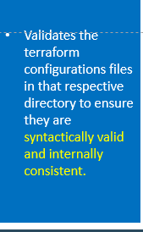

1. **terraform plan:** Terraform is very powerful b'cas you can check the outcome before you run terraform script. It helps us to understand what type of resources terraform is going to create/delete.

Syntax-

* terraform plan

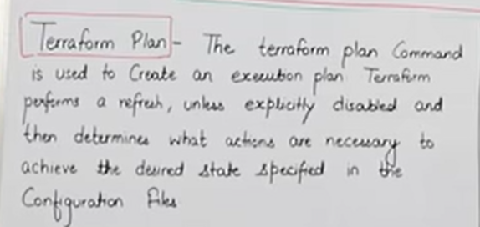

1. **terraform apply**: To run the terraform script/ **How to call specific terraform file.**

Whenever we do terraform apply it creates **terraform.tfstate** file(terraform configuration database) in your local working directory.

*Details about above file check in the “terraform file document”.*

Syntax-

* terraform apply
* terraform apply -auto-approve ….to auto approve the Yes/No condition

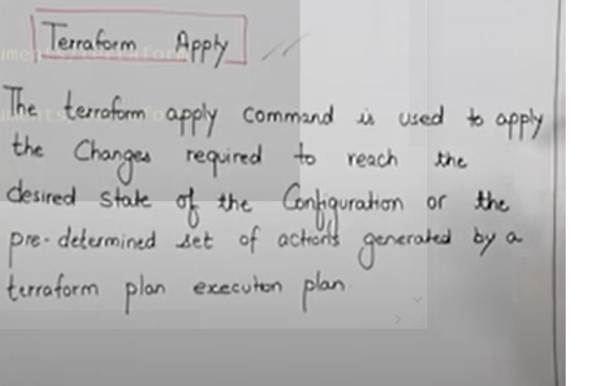

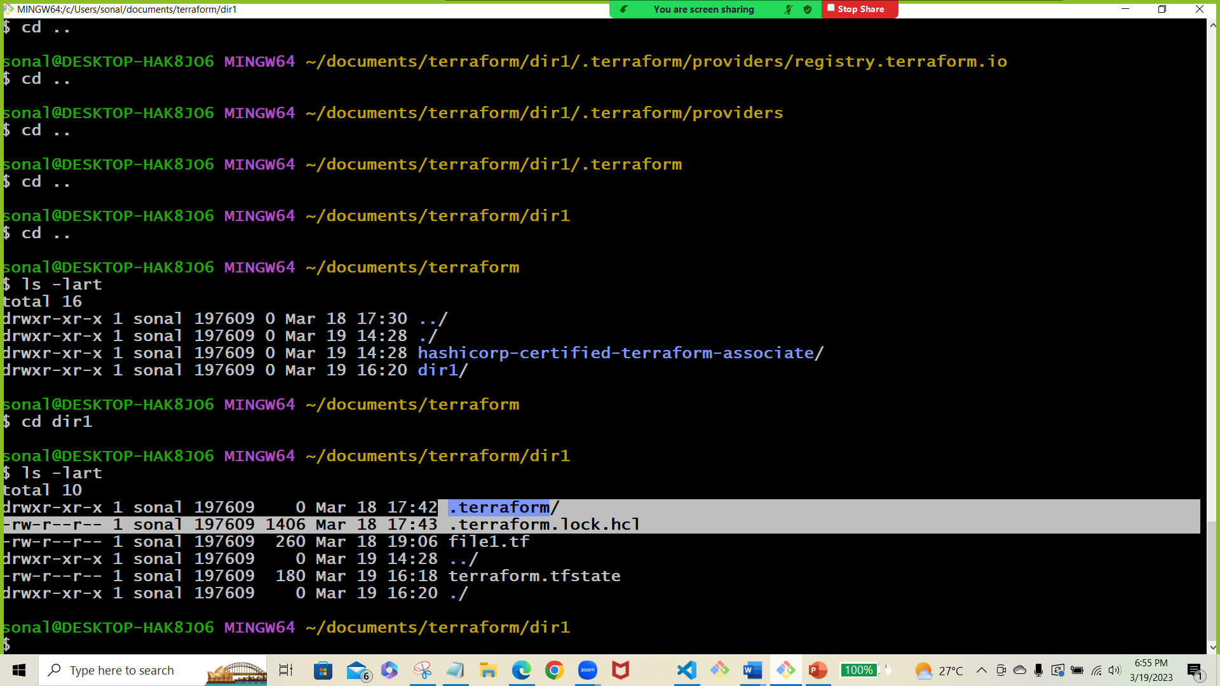

1. **terraform destroy:** To delete/destroy all the resources created by terraform.

Syntax-

* terraform destroy

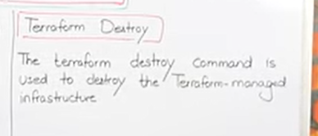

==============================================================================

**Advanced Terraform Commands-**

**terraform fmt-**

1. It slightly changes the terraform configuration file as per the terraform standards.
2. Whenever we use this command 1st time it shows the file name and when u will use it nd time it does not show the file names. It means files are modified.
3. The terraform fmt command is used to**rewrite Terraform configuration files to a canonical format and style**[1](https://www.bing.com/ck/a?!&&p=72b95dd0c4b0f06eJmltdHM9MTY3OTk2MTYwMCZpZ3VpZD0yNTA0MjBjZi0wZDUxLTYzMmUtMThkMS0zMDRmMGNjYTYyNjgmaW5zaWQ9NTQwMw&ptn=3&hsh=3&fclid=250420cf-0d51-632e-18d1-304f0cca6268&psq=about+terraform+fmt+command&u=a1aHR0cDovL21hbi5odWJ3aXouY29tL2RvY3NldC9UZXJyYWZvcm0uZG9jc2V0L0NvbnRlbnRzL1Jlc291cmNlcy9Eb2N1bWVudHMvZG9jcy9jb21tYW5kcy9mbXQuaHRtbA&ntb=1)[2](https://www.bing.com/ck/a?!&&p=53028a6e1450cdaeJmltdHM9MTY3OTk2MTYwMCZpZ3VpZD0yNTA0MjBjZi0wZDUxLTYzMmUtMThkMS0zMDRmMGNjYTYyNjgmaW5zaWQ9NTQwNA&ptn=3&hsh=3&fclid=250420cf-0d51-632e-18d1-304f0cca6268&psq=about+terraform+fmt+command&u=a1aHR0cHM6Ly9kb2NzLnczY3ViLmNvbS90ZXJyYWZvcm0vY29tbWFuZHMvZm10Lmh0bWw&ntb=1)[3](https://www.bing.com/ck/a?!&&p=9702c4b101ef1ce2JmltdHM9MTY3OTk2MTYwMCZpZ3VpZD0yNTA0MjBjZi0wZDUxLTYzMmUtMThkMS0zMDRmMGNjYTYyNjgmaW5zaWQ9NTQwNQ&ptn=3&hsh=3&fclid=250420cf-0d51-632e-18d1-304f0cca6268&psq=about+terraform+fmt+command&u=a1aHR0cHM6Ly93d3cudHlwZWVycm9yLm9yZy9kb2NzL3RlcnJhZm9ybS9jb21tYW5kcy9mbXQ&ntb=1). This command applies a subset of the Terraform language style conventions and other minor adjustments for readability[1](https://www.bing.com/ck/a?!&&p=c02b1fb77d4d39c9JmltdHM9MTY3OTk2MTYwMCZpZ3VpZD0yNTA0MjBjZi0wZDUxLTYzMmUtMThkMS0zMDRmMGNjYTYyNjgmaW5zaWQ9NTQwNg&ptn=3&hsh=3&fclid=250420cf-0d51-632e-18d1-304f0cca6268&psq=about+terraform+fmt+command&u=a1aHR0cDovL21hbi5odWJ3aXouY29tL2RvY3NldC9UZXJyYWZvcm0uZG9jc2V0L0NvbnRlbnRzL1Jlc291cmNlcy9Eb2N1bWVudHMvZG9jcy9jb21tYW5kcy9mbXQuaHRtbA&ntb=1)[4](https://www.bing.com/ck/a?!&&p=6f955f50072aa4e2JmltdHM9MTY3OTk2MTYwMCZpZ3VpZD0yNTA0MjBjZi0wZDUxLTYzMmUtMThkMS0zMDRmMGNjYTYyNjgmaW5zaWQ9NTQwNw&ptn=3&hsh=3&fclid=250420cf-0d51-632e-18d1-304f0cca6268&psq=about+terraform+fmt+command&u=a1aHR0cHM6Ly9zcGFjZWxpZnQuaW8vYmxvZy90ZXJyYWZvcm0tZm10&ntb=1). It can scan the current directory or a given directory for configuration files[2](https://www.bing.com/ck/a?!&&p=d470e4149f7e2dfdJmltdHM9MTY3OTk2MTYwMCZpZ3VpZD0yNTA0MjBjZi0wZDUxLTYzMmUtMThkMS0zMDRmMGNjYTYyNjgmaW5zaWQ9NTQwOA&ptn=3&hsh=3&fclid=250420cf-0d51-632e-18d1-304f0cca6268&psq=about+terraform+fmt+command&u=a1aHR0cHM6Ly9kb2NzLnczY3ViLmNvbS90ZXJyYWZvcm0vY29tbWFuZHMvZm10Lmh0bWw&ntb=1)[3](https://www.bing.com/ck/a?!&&p=3e63889dd50ec6f2JmltdHM9MTY3OTk2MTYwMCZpZ3VpZD0yNTA0MjBjZi0wZDUxLTYzMmUtMThkMS0zMDRmMGNjYTYyNjgmaW5zaWQ9NTQwOQ&ptn=3&hsh=3&fclid=250420cf-0d51-632e-18d1-304f0cca6268&psq=about+terraform+fmt+command&u=a1aHR0cHM6Ly93d3cudHlwZWVycm9yLm9yZy9kb2NzL3RlcnJhZm9ybS9jb21tYW5kcy9mbXQ&ntb=1). It is a best practice to run this command on your configuration files for consistency[1](https://www.bing.com/ck/a?!&&p=fcfe802e30bbb74eJmltdHM9MTY3OTk2MTYwMCZpZ3VpZD0yNTA0MjBjZi0wZDUxLTYzMmUtMThkMS0zMDRmMGNjYTYyNjgmaW5zaWQ9NTQxMA&ptn=3&hsh=3&fclid=250420cf-0d51-632e-18d1-304f0cca6268&psq=about+terraform+fmt+command&u=a1aHR0cDovL21hbi5odWJ3aXouY29tL2RvY3NldC9UZXJyYWZvcm0uZG9jc2V0L0NvbnRlbnRzL1Jlc291cmNlcy9Eb2N1bWVudHMvZG9jcy9jb21tYW5kcy9mbXQuaHRtbA&ntb=1)[4](https://www.bing.com/ck/a?!&&p=dc7578bf4758bcdfJmltdHM9MTY3OTk2MTYwMCZpZ3VpZD0yNTA0MjBjZi0wZDUxLTYzMmUtMThkMS0zMDRmMGNjYTYyNjgmaW5zaWQ9NTQxMQ&ptn=3&hsh=3&fclid=250420cf-0d51-632e-18d1-304f0cca6268&psq=about+terraform+fmt+command&u=a1aHR0cHM6Ly9zcGFjZWxpZnQuaW8vYmxvZy90ZXJyYWZvcm0tZm10&ntb=1).

**terraform get-**

* terraform get: It is the command to allow the tool for downloading and updating the existing modules within the root.
* Terraform get –update=true: It is the command under which the downloaded modules will be checked for available updates. If found, then those modules will be updated.

**terraform debug-**

**terraform import-**

**terraform graph-**

==============================================================================

**Workspace related commands-**

==============================================================================

**Terraform commands- State Perspective**

